FACULTY EVALUATION
Programme Name: SBVP ALUMNI MASTERCLASS - GROW Online Tanzania (23rd March 2026 - 27th March 2026)
Session: Reflections and Way Forward
Faculty Name: Dr. Nancy Nyambura Njiraini
No. of Respondents: 7
No. of Participants: 10
Evaluation Parameter | (%) Individual Score | (%) Programme Average
Punctuality (Commencement and Completion of Sessions) | 96 | 96
How well do you understand the core concepts presented? | 96 | 95
Rate your confidence in applying the new skills learnt | 96 | 95
Degree of Faculty preparedness for the sessions | 96 | 96
Content and methodology of the program | 96 | 97
Quality of class and group discussions | 96 | 95
The information presented in the course is relevant to my work (ministry) | 96 | 94
Average scores | 96 | 95

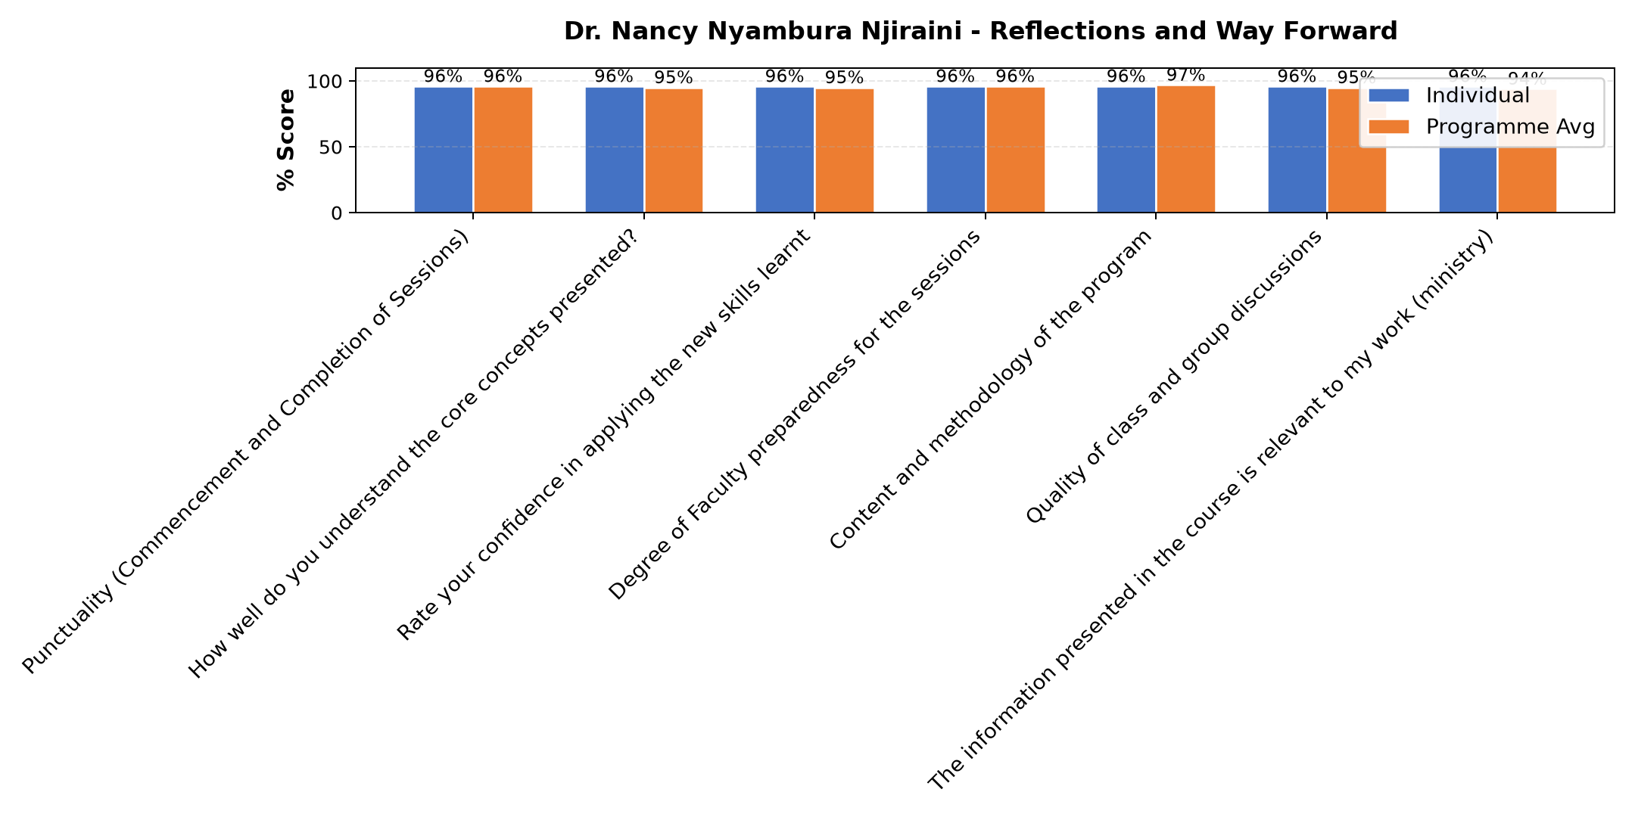

Comments & Feedback
- • Internet
- • Financial
- • Lacking follow up in my social enterprise
- • Thanks
- • It was great
- • Well done
- • Well presented
SUBMITTED THROUGH:
SBS Evaluation Automation System

